**Assignment – 1**

**MODULE 1 :** SE – Overview of IT Industries.

1. What is software ? What is software engineering.

* Software : Software is a set of instructions, data or programs used to operate computers and execute specific tasks.
* Software Engineering : Software engineering is the application of principles used in the field of engineering, which usually deals with physical systems, to the design, development, testing, deployment and management of software systems.

1. Explain types of software.

There are four types of software such as :

1. Application Software : This is the most common type of computer software, and can be defined as end-user programs that help you perform tasks or achieve a desired outcome. The end-user is the person who is actually using a product or program.
2. System Software : System software helps the user, the computer or mobile device, and an application all work together seamlessly. This makes system software crucial to running any kind of application software as well as the whole computer system.
3. Programming Software : While application software is designed for end-users, and system software is designed for computers or mobile devices, programming software is for computer programmers and developers who are writing code. These are programs that are used to write, develop, test, and debug other software programs.
4. Driver Software : This software is often considered to be a type of system software. Driver software operates and controls devices that are plugged into a computer. These drivers make it possible for devices to perform their necessary functions. A very good (and practical) example of this is your printer.
5. What is SDLC ? Explain each phase of SDLC.

Software Development Life Cycle is the application of standard business practices to building software applications. It’s typically divided into six to eight steps: Planning, Requirements, Design, Build, Document, Test, Deploy, Maintain.

1. Planning : In the Planning phase, project leaders evaluate the terms of the project. This includes calculating labor and material costs, creating a timetable with target goals, and creating the project’s teams and leadership structure.
2. Define Requirements : Defining requirements is considered part of planning to determine what the application is supposed to do and its requirements. For example, a social media application would require the ability to connect with a friend. An inventory program might require a search feature. Requirements also include defining the resources needed to build the project.
3. Design : In this third phase, the system and software design documents are prepared as per the requirement specification document. This helps define overall system architecture. This design phase serves as input for the next phase of the model.
4. Coding : Once the system design phase is over, the next phase is coding. In this phase, developers start build the entire system by writing code using the chosen programming language. In the coding phase, tasks are divided into units or modules and assigned to the various developers. It is the longest phase of the Software Development Life Cycle process. In this phase, Developer needs to follow certain predefined coding guidelines.
5. Testing : Once the software is complete, and it is deployed in the testing environment. The testing team starts testing the functionality of the entire system. This is done to verify that the entire application works according to the customer requirement. During this phase, QA and testing team may find some bugs/defects which they communicate to developers.
6. Installation/Deployment : Once the software testing phase is over and no bugs or errors left in the system then the final deployment process starts. Based on the feedback given by the project manager, the final software is released and checked for deployment issues if any.
7. Maintenance : Once the system is deployed, and customers start using the developed system, following 3 activities occur such as
8. Bug fixing – bugs are reported because of some scenarios which are not tested at all
9. Upgrade – Upgrading the application to the newer versions of the Software
10. Enhancement – Adding some new features into the existing software
11. What is DFD ? Create a DFD diagram on Flipkart.

A data flow diagram (DFD) is a graphical or visual representation using a standardized set of symbols and notations to describe a business's operations through data movement.

DFD diagram on Flipkart :

1. What is Flow Chart ? Create a flowchart to make addition of two numbers.

A flowchart is a diagram that depicts a process, system or computer algorithm.

Flowchart to make addition of two numbers :

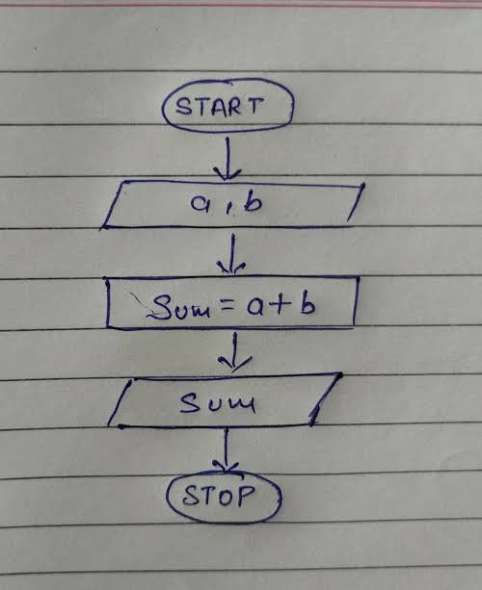

1. What is Use case Diagram ? Create a use-case on bill payment on Paytm.

Use-case diagrams describe the high-level functions and scope of a system. These diagrams also identify the interactions between the system and its actors.

Create a use-case on bill payment on Paytm :